OPENGL
OpenGL is a software interface to graphics hardware that consists of distinct commands (in core OpenGL and in OpenGL Utility Library) to produce interactive 2D and 3D applications
It was designed as hardware independent interface to be implemented on different hardware platforms for building models that are built up from a small set of geometric primitives – points, lines, polygons.
So the programmer does not need to be aware of the type of hardware platform the program developed by him will be deployed on, he develops the program using OpenGL API and that program can be run on all hardware that are built following the OpenGL standard
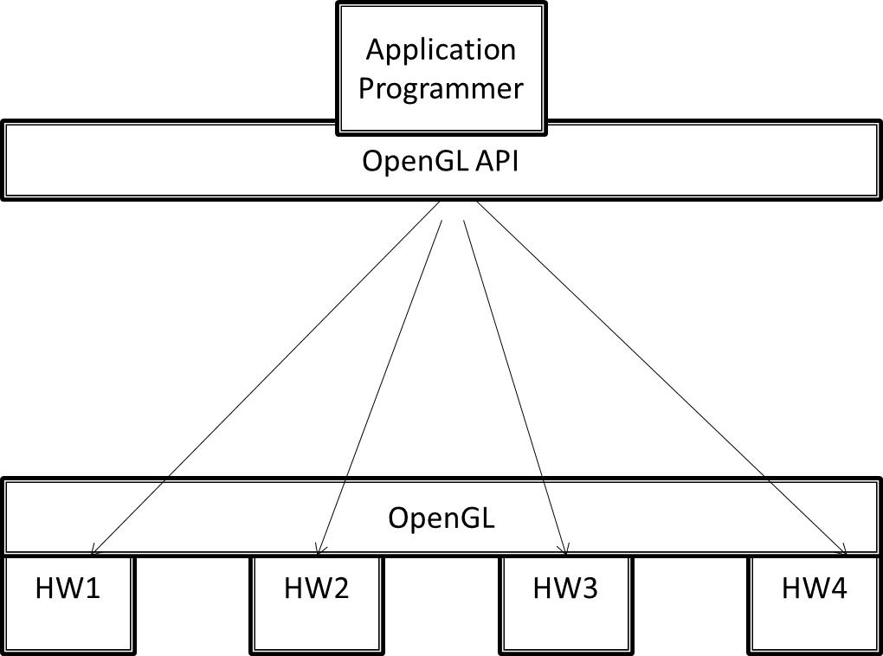
It is an operating system and hardware platform independent graphics library designed to be easily portable yet rapidly executable. It brings a standard 3D graphics library with the hardware enhanced ability to perform lighting , shading, texture mapping, hidden surface removal and animation on to the windows platform
Open GL is available on a variety of hardware platforms and operating systems. OpenGL was written with the express intention of becoming a thin software interface to underlying graphics hardware an arrangement of proven success in the graphics workstation market.
Application Program
OpenGL/DirectX API
GPU: Graphics Card
Monitor
Mouse
Keyboard

Features of Open GL:
Texture Mapping : The ability to apply an image to a graphics surface, this technique is used to rapidly generate realistic images without having to specify on excessive amount of detail regarding pixel coordinates, textures etc
Z-Buffering: The ability to calculate the distance from the viewer’s location. this makes it easy for the program to automatically remove surface or parts of surfaces that are hidden from view
Double Buffering: Support for smooth animation using double buffering. A smooth animation sequence is achieved by drawing into the back buffer while displaying the front buffer and then swapping the buffers when ready to display the next animation sequence
Lighting Effects: The ability to calculate the effects on the lightness of a surface’s color when different lighting models are applied to the surface from one or more light sources
Smooth Shading: The ability to calculate the shading effect that occurs when light hits a surface at an angle and results in subtle color differences across the surface. This effect is important for making model look realistic
Material Properties: The ability to specify the material properties of a surface. These properties modify the lighting effects on the surface by specifying such this as dullness or shininess of the surface
Alpha Blending: The ability to specify alpha or opacity value in addition to the regular red , green, blue values. The alpha component is used to specify opacity, allowing the full range from completely transparent to totally opaque. When used in combination with z buffer, Alpha blending gives the effect of being able to see through objects

Developer’s Advantage:
Industry Standard: the Open GL architecture Review board an independent consortium guides the Open GL specification Open GL is the only true open vendor-neutral, multiplatform graphics standard with a broad industry support
Stability: Updating to Open GL specification are carefully controlled and updates are announced in time for developers to adopt changes. Backward compatibility requirements ensure the viability of existing applications
Portability: applications produce consistent visual display result on any OpenGL API compliant hardware regardless of OS or windowing system. So once a program is written for any platform, it can be ported for other platforms as well.
Evolving: New hardware innovations are accessible thru the API via the OpenGL extension mechanism Innovations are phased in to enable developers and hardware vendors to incorporate new features into their product release cycles
Scalability: Open GL applications can be scaled to any class of machine, everything from consumer electronics to PCS, workstations, Super Computers
Ease of Use: Efficient OpenGL routines typically result in applications with fewer lines of code than programs created with other graphics libraries or packages. OpenGL driver encapsulates the information about the underlying hardware so the application programmer does not need to b e concerned about having to design for specific hardware features
History
OpenGL was first created as an open and reproducible alternative to Iris GL which had been the proprietary graphics API on Silicon Graphics workstations.
Although OpenGL was initially similar in some respects to IrisGL the lack of a formal specification and conformance tests made Iris GL unsuitable for broader adoption. Mark Segal and Kurt Akeley authored the OpenGL 1.0 specification which tried to formalize the definition of a useful graphics API and made cross platform non-SGI 3rd party implementation and support viable. One notable omission from version 1.0 of the API was texture objects.
IrisGL had definition and bind stages for all sorts of objects including materials, lights, textures and texture environments. OpenGL avoided these objects in favor of incremental state changes with the idea that collective changes could be encapsulated in display lists. This has remained the philosophy with the exception that texture objects (glBindTexture) with no distinct definition stage are a key part of the API.
OpenGL has been through a number of revisions which have predominantly been incremental additions where extensions to the core API have gradually been incorporated into the main body of the API. For example OpenGL 1.1 added the glBindTexture extension to the core API.
OpenGL 2.0 incorporates the significant addition of the OpenGL Shading Language (also called GLSL), a C like language with which the transformation and fragment shading stages of the pipeline can be programmed.
OpenGL 3.0 adds the concept of deprecation: marking certain features as subject to removal in later versions. GL 3.1 removed most deprecated features, and GL 3.2 created the notion of core and compatibility OpenGL contexts.
Official versions of OpenGL released to date are 1.0, 1.1, 1.2, 1.2.1, 1.3, 1.4, 1.5, 2.0, 2.1, 3.0, 3.1, 3.2, 3.3, 4.0, 4.1, 4.2, 4.3, 4.4, 4.5.

General OpenGL Architecture
Application

OpenGL API
GLU
glu32.dll
Windowing API
wgl

Display Management System
Hardware Specific OpenGL Driver
Generic Software OpenGL Driver
Hardware

Block Diagram of Typical Application / OpenGL / OS interactions.
OpenGL is the definitive cross-platform 3D library.
- The Application module is developed by the programmer
- Windowing API functions specifically developed to support OpenGL are used to set up, shut down, and handles event signals from an OpenGL drawing area called a Rendering Context (RC) in a window or component . These functions may be defined by the operating system, third party widget set, or by a cross platform OpenGL library.
  - OS Defined Libraries:
    - Windows: WGL functions
    - XWindows (Linux, most UNIXs): GLX functions
    - Mac OS X: AGL, CGL, NSOpenGL classes
  - Cross Platform OpenGL Libraries
    - SDL
    - GLUT (pronounced gloot)
  - Cross Platform Widget Sets with OpenGL support
    - wxWidgets
    - fltk
    - tcl/tk
    - Qt
- OpenGL API functions defined in OpenGL.h and provided by the active OpenGL driver (specified by the RC) are used to draw.
  - There are some optional helper functions defined in glu.h which simplify some of the more complex OpenGL tasks.
  - Some of the Special OpenGL libraries also provide special drawing functions for certain shapes or text.
- OpenGL Drivers implement the details of OpenGL functions either by passing data directly to 3D hardware, performing computations on the main CPU or some combination of the two.
  - Whether the programmer will render with dedicated hardware or with a software implementation is determined by what OpenGL features the programmer requests with the Windowing API and what the computer's hardware supports.

Model-View-Controller Architecture
Interactive program design involves breaking the program into three parts:
- The Model: all the data that are unique to the program reside there. This might be game state, the contents of a text file, or tables in a database.
- The View of the Model: it is a way of displaying some or all of the data to user. Objects in the game state might be drawn in 3D, text in the file might be drawn to the screen with formatting, or queries on the database might be wrapped in HTML and sent to a web browser.
- The Controller: the methods for user to manipulate the model or the view. Mouse and keystrokes might change the game state, select text, or fill in and submit a form for a new query.
Object-oriented programming was developed, in part, to aid with modularising the components of Model-View-Architecture programs. Most user interface APIs are written in an Object Oriented language.
Structuring programs to handle these three aspects of an interactive program. A 3D graphics:
- Model consists of descriptions of the geometry, positioning, apperance and lighting in your scene. Ideally these could be saved to and loaded from a file.
- View consists of the OpenGL rendering calls that set up your rendering area, interpret the document, and send things to be drawn.

Controller is usually a set functions you write that respond to event signals sent to your program via the Windowing API.

OpenGL Rendering Pipeline
1. Vertex Processing:
Each vertex in the vertex array is processed in turn into an output vertex .
It then goes through tessellation stages and geometry shader primitive processing for producing a sequence of primitives.
2. Vertex Post-Processing:
Outputs of the last stage are adjusted or shipped to different locations.
Transform Feedback happens here like Primitive Assembly, Primitive Clipping, the perspective
divide, and the viewport transform to window space.
3. Scan conversion and primitive parameter interpolation, which generates a number of Fragments.
4. A Fragment Shader processes each fragment. Each fragment generates a number of outputs.
5. Per-Sample Processing, including but not limited to:
Scissor Test, Stencil Test, Depth Test, Blending, Logical Operation, Write Mask
Vertex Specification
The application sets up an ordered list of vertices, that define the boundaries of a primitive (triangles, lines, and points), to send to the pipeline.
This part of the pipeline deals with a number of objects like
Vertex Array Objects that define what data each vertex has
Vertex Buffer Objects store the actual vertex data itself
A vertex's data is a series of attributes.
Once the vertex data is properly specified, it is then rendered as a Primitive via a drawing command.
Vertex Processing
Vertices fetched due to prior vertex rendering stage begin their processing here.
Vertex processing stages are almost all programmable operations allowing user code to customize the
way vertices are processed.
Each stage represents a different kind of shader operation.
Vertex shader
Vertex shaders receive attribute inputs from vertex rendering and converts each incoming vertex into a single outgoing vertex based on an arbitrary, user-defined program
Vertex shaders can have user-defined outputs, but there is also a special output that represents the final position of the vertex.
Tessellation
Primitives can be tessellated using two shader stages and a fixed-function tessellator between them.
The Tessellation Control Shader (TCS) stage determines the amount of tessellation to apply to a primitive, as well as ensuring connectivity between adjacent tessellated primitives.
The Tessellation Evaluation Shader (TES) stage applies interpolation or other operations used to compute user-defined data values for primitives generated by the fixed-function tessellation process.
Geometry Shader
Geometry shaders are user-defined programs that process each incoming primitive, returning zero or more output primitives.
Input primitives for geometry shaders are output primitives from a subset of Primitive Assembly process. If a triangle strip is sent as a single primitive, geometry shader will see it as a series of triangles.
Geometry shaders can convert primitives to different types; input point primitives can become triangles, or lines can become points.
Vertex post-processing
After shader-based vertex processing, vertices undergo a number of fixed-function processing steps.
Transform Feedback
Outputs of geometry shader or primitive assembly can be written to series of buffer objects that have been setup for this purpose.
This is called transform feedback mode; it allows the user to transform data via vertex and geometry shaders, then hold on to that data for use later.
The data output into the transform feedback buffer is the data from each primitive emitted by this step.
Primitive assembly
Primitive assembly is the process of collecting a run of vertex data output from the prior stages and composing it into a sequence of primitives.
The output of this process is an ordered sequence of simple primitives (lines, points, or triangles). If the input is a triangle strip primitive containing 12 vertices, for example, the output of this process will be 10 triangles. Why??
Clipping
The primitives are then clipped.
Face culling
Triangle primitives can be culled (i.e. discarded without rendering) based on the triangle's facing in window space.
This allows you to avoid rendering triangles facing away from the viewer.
Rasterization
Primitives are then rasterized in the order in which they were given.
The result of rasterizing a primitive is a sequence of Fragments (fragment is a set of state that is used to compute final data for a pixel in output framebuffer)
Fragment State includes
- Position in screen-space
- Sample coverage
- List of arbitrary data that was output from the previous vertex or geometry shader
This last set of data is computed by interpolating between the data values in vertices for fragment
Fragment Processing
The data for each fragment from the rasterization stage is processed by a fragment shader.
Fragment shader Output
- List of colors for each of the color buffers being written to,
- Depth value
Per-Sample Operations
Fragment data output from fragment processor is then passed through a sequence of steps.
First step is a sequence of culling tests:
If a test is active and the fragment fails the test, the underlying pixels/samples are not updated (usually). The tests are:
• Pixel ownership test: Fails if the fragment's pixel is not "owned" by OpenGL
Always passes when using a Framebuffer Object. Failure means that pixel contains undefined values.
• Scissor Test: When enabled, the test fails if the fragment's pixel lies outside of a specified rectangle of the screen.
• Depth Test: When enabled, the test fails if the fragment's depth does not compare as the user specifies against the depth value from the underlying sample in the depth buffer.
Second Step Color blending:
For each fragment color value, there is a specific blending operation between it and the color already in the framebuffer at that location.
Logical Operations may also take place in lieu of blending, which perform bitwise operations between the fragment colors and framebuffer colors.
Final Step Fragment data is written to Framebuffer.
Masking operations allow the user to prevent writes to certain values.
Color, depth, and stencil writes can be masked on and off; individual color channels can be masked as well.

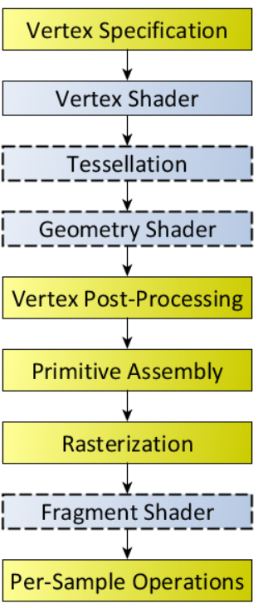

OpenGL Command Syntax
Uses the prefix gl and initial capital letters for each word making up the command name
e.g. glClearColor(---------); glVertex3f(---------);
OpenGL defined constants begin with GL and use all capital letters and underscores to separate words e.g. GL_COLOR_BUFFER_BIT

#include <necessary header files>
main(){
InitializeWindow();
Rendering operations();
UpdateWindowAndCheckForEvents();
}

Data types
Data type Corresponding C language OpenGL Type Definition
8 bit integer signed char GLbyte
16 bit integer short GLshort
32 bit integer int or long GLint, GLsizei
32 bit float float GLfloat
64 bit float double GLdouble

GL Related Libraries
OpenGL Utility Library (GLU): Contains several routines that use lower level OpenGL Commands to perform tasks as setting up matrices, for specific viewing orientations and projections etc. e.g. gluPerspective(…………..);

OpenGL Utility Toolkit (GLUT): A window system independent toolkit written by Mark Kilgard to hide the complexities of differing system APIs
OpenGL contains only rendering commands and no commands for opening windows or reading events from keyboard or mouse
GLUT provides several routines for opening windows detecting input and creating complicated 3D objects like spehere , torus , teapot
GLUT routines use the prefix glut e.g. glutCreateWindow(…); glutInit(…); glutMouseFunc(…..); glutKeyboardFunc(…..);

Windows Management
Five routines perform tasks necessary for initializing a window
glutInit(int *argc, char **argv)
- Initializes glut and processes any command line arguments
glutInit();
- should be called before any other GLUT routine
glutInitDisplayMode(unsigned int mode)
- specifies whether to use an RGBA or color-index model
- specifies whether to use a single or double buffered window and specify a depth buffer
glutInitDisplayMode(GLUT_SINGLE|GLUT_RGBA|GLUT_DEPTH);
glutInitWindowPosition(int x, int y)
- specifies screen location for the upper loft corner of your window
glutInitWindowSize(int x, int y)
- specifies the size in pixels of your window
glutCreateWindow(char *string)
- creates a window with the name that you supplies as the string (pointer) variable

The Display Callback
glutDisplayFunc(void (*func)(void))
- The first and most important event callback function
- Whenever GLUT determines that the contents of the window need to be redisplayed the call back function registered by glutDisplayFunc() is executed
- All the routines needed to redraw the scene are placed here
glutMainLoop()
- This is an infinite loop
- All the windows that have been created are now shown infinitely

A callback function is a function in which a function passed as an argument to another function
They are used to execute code in response to an event like a mouse click, keyboard press etc

Handling input events
Use the following routines to register callback commands that are invoked when specified events occur
glutReshapeFunc(void (*func)(int w, int h))
- Indicates what action should be taken when the window is resized
glutKeyboardFunc(void (*func)(unsigned char key, int x, int y))
glutMouseFunc(void (*func)(int button, int state, int x, int y))
- Allow you to link a keyboard key or a mouse button with a routine that’s invoked when the key or mouse button is pressed or released

Managing a background process
glutIdleFunc((*func)(void))
- Used to specify a function that’s to be executed if no other events are pending
- This routine takes a pointer to a function as its only argument

Examples

#include <windows.h>
#include <gl/glut.h>
#include <gl/glu.h>
void display(){
}
void main(int argc, char **argv){
glutInit(&argc,argv);
glutInitDisplayMode(GLUT_SINGLE|GLUT_RGB);
glutInitWindowPosition(100,100);
glutInitWindowSize(100,100);
glutCreateWindow("saroj");
glutDisplayFunc(display);
glutMainLoop();
}
//CLEARING THE BACKGROUND
void display(){
glClearColor(1.0,0.0,1.0,1.0);
glClear(GL_COLOR_BUFFER_BIT);
glFlush();
}

// PLOTTING A POLYGON: ADDED INSIDE DISPLAY FUNCTION
glShadeModel(GL_SMOOTH);
glBegin(GL_POLYGON);
glVertex3f(0.25, 0.25, 0.0);
glVertex3f(0.75, 0.25, 0.0);
glVertex3f(0.75, 0.75, 0.0);
glVertex3f(0.25, 0.75, 0.0);
glEnd();

//ADDED TO DRAW A POLYGON
void display(){
glClearColor(1.0,0.0,1.0,1.0);
glClear(GL_COLOR_BUFFER_BIT);
glShadeModel(GL_FLAT);
glColor3f(0.0,1.0,0.0);
// TO SPECIFY FILL COLOR
glBegin(GL_POLYGON);
glVertex3f(0.25, 0.25, 0.0);
glVertex3f(0.75, 0.25, 0.0);
glVertex3f(0.75, 0.75, 0.0);
glVertex3f(0.25, 0.75, 0.0);
glEnd();
glFlush();
}

More Examples

To create a window

#include <windows.h>
#include <gl/gl.h>
#include <gl/glut.h>
#include <gl/glu.h>
void display(){

}
void main(int argc, char **argv){
glutInit(&argc,argv);
glutInitDisplayMode(GLUT_SINGLE|GLUT_RGB);
glutInitWindowPosition(111,111);
glutInitWindowSize(200,100);
glutCreateWindow("dsaroj");
glutDisplayFunc(display);
glutMainLoop();}

To clear the background to a desired color, add these code to the display function
void display(){
glClearColor(1.0,0.0,1.0,1.0);
glClear(GL_COLOR_BUFFER_BIT);
glFlush();
}

Drawing a Triangle

static GLfloat x = 0.15;
void display(){
glClearColor(1.0,1.0,1.0,1.0);
glClear(GL_COLOR_BUFFER_BIT);
glColor3f(0.0,0.0,1.0); //fill color
glBegin(GL_POLYGON);
glVertex3f(0.0,0.0,0.0);
glVertex3f(50.0,0.0,0.0);
glVertex3f(25.0,50.0,0.0);
glEnd();
glFlush();
}

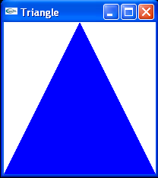

void reshape(int w, int h){
glViewport(0,0,w,h);
glMatrixMode(GL_PROJECTION);
glLoadIdentity();
glOrtho(0,50,0,50,-1,1);
//glOrtho(left,right,bottom,top,near,far);
glMatrixMode(GL_MODELVIEW);
glLoadIdentity();
}

void main(int argc, char **argv){
glutInit(&argc,argv);
glutInitDisplayMode(GLUT_SINGLE|GLUT_RGB);
glutInitWindowPosition(200,200);
glutInitWindowSize(200,200);
glutCreateWindow("Triangle");
glutDisplayFunc(display);
glutReshapeFunc(reshape);
glutMainLoop();
}

GL_PROJECTION : Applies subsequent matrix operations to the projection matrix stack.
GL_MODELVIEW : Applies subsequent matrix operations to the modelview matrix stack.

Getting input from a Mouse

GLfloat x = 0.15;
void display(){
glClearColor(1.0,1.0,1.0,1.0);
glClear(GL_COLOR_BUFFER_BIT);
glColor3f(0.0,0.0,1.0);
glBegin(GL_POLYGON);
glVertex3f(0.25+x,0.25,0.0);
glVertex3f(0.75+x,0.25,0.0);
glVertex3f(0.75+x,0.75,0.0);
glEnd();
glFlush();
}

void trans(){
x = x-0.001;
glutPostRedisplay();
}
void mouse(int button, int state, int x, int y){
switch(button){
case GLUT_LEFT_BUTTON:
if (state == GLUT_DOWN)
glutIdleFunc(trans);
break;
case GLUT_RIGHT_BUTTON:
if (state == GLUT_DOWN)
glutIdleFunc(NULL);
break;
}

void main(int argc, char **argv){
glutInit(&argc,argv);
glutInitDisplayMode(GLUT_SINGLE|GLUT_RGB);
glutInitWindowPosition(111,111);
glutInitWindowSize(200,100);
glutCreateWindow("saroj");
glutDisplayFunc(display);
glutMouseFunc(mouse);
glutMainLoop();}

Getting input from a Keyboard
GLfloat x = 0.15;
void display(){
glClearColor(1.0,1.0,1.0,1.0);
glClear(GL_COLOR_BUFFER_BIT);
glColor3f(0.0,0.0,1.0);
glBegin(GL_POLYGON);
glVertex3f(0.25+x,0.25,0.0);
glVertex3f(0.75+x,0.25,0.0);
glVertex3f(0.75+x,0.75,0.0);
glEnd();
glFlush();
}

void trans(){
x = x-0.001;
glutPostRedisplay();
}
void key(unsigned char key, int x, int y){
switch(key){
case 'a':
glutIdleFunc(trans);
break;
case 'f':
glutIdleFunc(NULL);
break;
}
}

To rotate a triangle
glRotatef(type angle, type x, type y, type z);
multiplies current matrix by a matrix that rotates an object in counter clockwise direction
glTranslatef(type x, type y, type z);
multiplies current matrix by a matrix that translates an object by th e give x, y , z values
glScalef(type x, type y, type z);
multiplies current matrix by a matrix that stretches or shrinks an object

Smooth Shading (Intensity Interpolation Scheme)
#include <windows.h>
#include <gl/gl.h>
#include <gl/glu.h>
#include <gl/glut.h>
#include <stdlib.h>
#include <math.h>

Draw triangle with three vertices with different colors
void display(){
glClearColor(0.0,0.0,0.0,0.0);
//glShadeModel(GL_FLAT); //CIS
glShadeModel(GL_SMOOTH); //Gouroud Shading
glClear(GL_COLOR_BUFFER_BIT);
glutWireSphere(1.0,20,16);
glBegin(GL_TRIANGLES);
glColor3f(0.0,1.0, 0.0); //green
glVertex2f(25.0, 5.0);

glColor3f(0.0,0.0, 1.0); //blue
glVertex2f(5.0, 25.0);

glColor3f(1.0,0.0, 0.0); //red
glVertex2f(5.0, 5.0);
glEnd();
glFlush();
}

Define Coordinate System and create view port

void reshape(int w,int h){
glViewport(0,0,(GLsizei)w,(GLsizei)h);
glMatrixMode(GL_PROJECTION);
glLoadIdentity();
if(w<= h)
gluOrtho2D(0.0,250.0,0.0,250.0);
else
gluOrtho2D(0.0,30.0,0.0,30.0*(GLfloat)h/(GLfloat)w);
glMatrixMode(GL_MODELVIEW);

}
int main(int argc, char* argv[]){
glutInit(&argc,argv);
glutInitDisplayMode(GLUT_RGB|GLUT_SINGLE);
glutInitWindowPosition(100,100);
glutInitWindowSize(600,600);
glutCreateWindow("Intensity Interpolation Scheme");
glutDisplayFunc(display);
glutReshapeFunc(reshape);
glutMainLoop();
return 0;
}

//Animation using Double Buffer
#include <windows.h>
#include <gl/gl.h>
#include <gl/glu.h>
#include <gl/glut.h>
static GLfloat spins= 0.0;

//Create a rectangle
void display(){
glClearColor(0.0,0.0,0.0,0.0);
glShadeModel(GL_FLAT);
glClear(GL_COLOR_BUFFER_BIT);
glPushMatrix();
glRotatef(spins,0.0,0.0,1.0);
glColor3f(1.9,1.0,0.8);
glRectf(-25.0,-25.0,25.0,25.0);
glPopMatrix();
glutSwapBuffers();
}

//Function for changing the value of spins
void spin(){
spins = spins + 2;
if( spins > 360.0 )
spins = spins - 360.0;
glutPostRedisplay();
}

//Trap mouse click event
void mouse(int button,int state, int x, int y){
switch(button){
case GLUT_LEFT_BUTTON:
if(state == GLUT_DOWN)
glutIdleFunc(spin); //NULL to Pause
break;
}
}

//Specify coordinate system
void reshape(int w, int h){
glViewport(0,0,(GLsizei)w,(GLsizei)h);
glMatrixMode(GL_PROJECTION);
glLoadIdentity();
glOrtho(-50.0,50.0,-50.0,50.0,-1.0,1.0);
glMatrixMode(GL_MODELVIEW);
glLoadIdentity();
}
void main(int argc, char* argv[ ]){
glutInit(&argc,argv);
glutInitDisplayMode(GLUT_DOUBLE|GLUT_RGB);
glutInitWindowSize(500,500);
glutInitWindowPosition(100,100);
glutCreateWindow("Animation");
glutDisplayFunc(display);
glutReshapeFunc(reshape);
glutMouseFunc(mouse);
glutMainLoop();
}

Basic Transformations
OpenGL provides API for performing basic 2D and 3D transformations
Translation: glTranslate*(tx, ty, tx)
Here tx, ty, tx are the translation factors, the suffix * may be a f (float) or d (double)
Rotation: glRotate(theta, vx, vy, vz)
Here vx, vy and vz are orientation for a rotation axis that passes through coordinate origin
theta is the rotation angle in degrees
Scale: glScale*(sx, sy, sz)
Here sx, sy and sz are scaling factors

Projections
The gluLookAt function creates a viewing matrix derived from an eye point, a reference point indicating the center of the scene, and an up vector.
void gluLookAt( GLdouble eyex, GLdouble eyey, GLdouble eyez,
GLdouble centerx, GLdouble centery, GLdouble centerz,
GLdouble upx, GLdouble upy, GLdouble upz );
Parameters
eyex, eyey, eyez The position of the eye point.
centerx, centery, centerz The position of the reference point.
upx, upy, upz The direction of the up vector.

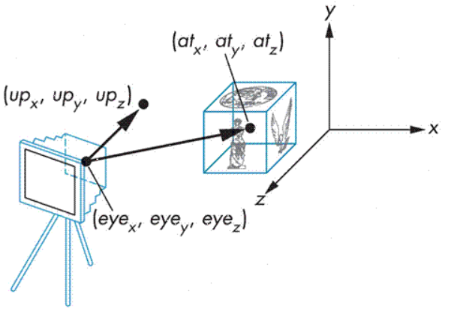
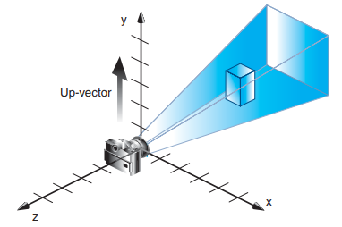
gluLookAt(4.0, 2.0, 1.0, 2.0, 4.0, -3.0, 2.0, 2.0, -1.0)
The camera position (eyex, eyey, eyez) is at (4, 2, 1).
The camera is looking right at the model, so the reference point is at (2, 4, –3).
An orientation vector of (2, 2, –1) is chosen to rotate the viewpoint to this 45-degree angle
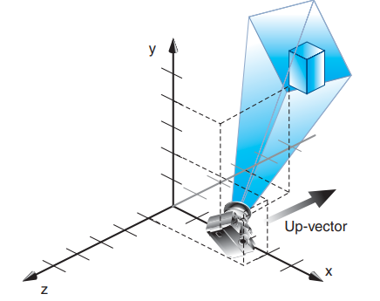
Orthographic Projection
void glOrtho(GLdouble left, GLdouble right, GLdouble bottom, GLdouble top, GLdouble near, GLdouble far);
Creates a matrix for an orthographic parallel viewing volume and multiplies the current matrix by it.
(left, bottom, –near) and (right, top, –near) are points on the near clipping plane that are mapped to the lower left and upper right corners of the viewport window, respectively.
(left, bottom, –far) and (right, top, –far) are points on the far clipping plane that are mapped to the same respective corners of the viewport.
Both near and far may be positive, negative, or even set to zero. Near and far should not be the same value.
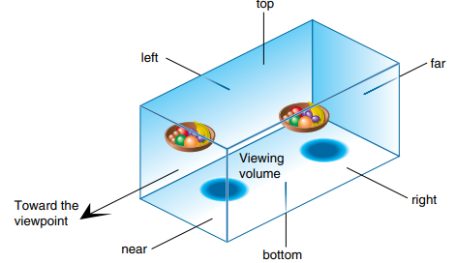

Perspective Projection
void gluPerspective(GLdouble fovy, GLdouble aspect, GLdouble near, GLdouble far);
Creates a matrix for a symmetric perspective-view frustum and multiplies the current matrix by it.
fovy is the angle of the field of view in the yz-plane; its value must be in the range [0.0, 180.0].
aspect is the aspect ratio of the frustum, its width divided by its height.
near and far values are the distances between the viewpoint and the clipping planes, along the negative z-axis.
They should always be positive.
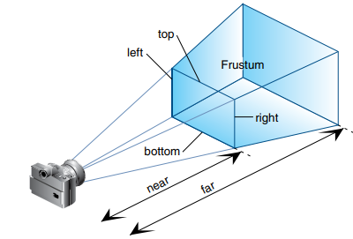
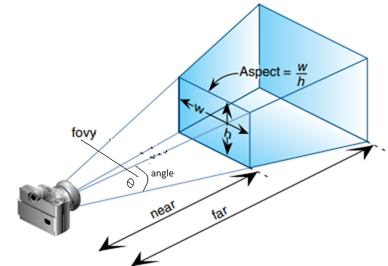

Lighting
glLightfv sets the values of individual light source parameters
glLightfv(GL_LIGHT0,GL_POSITION,position):
Set light-source parameters.
void glLightfv( GLenum light, GLenum pname, const GLfloat *params);

light
The identifier of a light
GL_LIGHTi where 0 ≤ i < GL_MAX_LIGHTS
At least eight lights are supported.
pname
A single-valued light-source parameter for light position
param
The value to which parameter pname of light source
light will be set.

glMaterial
glMaterial*() affect the colors of the diffuse, specular and ambient light reflected by an object

gLfloat mat_specular[ ] = {1,0,0,1};
glMaterialfv(GL_FRONT, GL_SPECULAR, mat_specular);
glEnable(GL_LIGHTING);
glEnable(GL_LIGHT0);
glEnable(GL_DEPTH_TEST);
glutSolidSphere(1.0, 20, 16);
glFlush();

Font Generation
#include <windows.h>
#include <gl/gl.h>
#include <gl/glut.h>
#include <gl/glu.h>
GLubyte rasters[24] = {
0xc0,0x00, 0xc0,0x00, 0xc0,0x00, 0xc0,0x00, 0xc0,0x00,
0xff,0x00, 0xff,0x00, 0xc0,0x00, 0xc0,0x00, 0xc0,0x00,
0xff,0xc0, 0xff,0xc0,
};
void init(){
glPixelStorei(GL_UNPACK_ALIGNMENT,1);
glClearColor(0.0,0.0,0.0,0.0);
}

void display(void){
glClear(GL_COLOR_BUFFER_BIT);
glColor3f(1,1,1);
glFlush();
}
void show(){
glRasterPos2i(20,20);
glBitmap(10,12,0,0,11,0,rasters);
glBitmap(10,12,0,0,11,0,rasters);
glBitmap(10,12,0,0,11,0,rasters);
glFlush();
}
void reshape(int w, int h){
glViewport(0,0,(GLsizei)w, (GLsizei)h);
glMatrixMode(GL_PROJECTION);
glLoadIdentity();
glOrtho(0, w,0 , h, -1.0,1.0);
glMatrixMode(GL_MODELVIEW);
}

void keyboard(unsigned char key, int x, int y){
switch(key){
case 'f':
show();
case 'a':
exit(0);
}
}

void main(int argc, char **argv){
glutInit(&argc,argv);
glutInitDisplayMode(GLUT_SINGLE|GLUT_RGB);
glutInitWindowSize(500,500);
glutInitWindowPosition(100,100);
glutCreateWindow(argv[0]);
init();
glutDisplayFunc(display);
glutReshapeFunc(reshape);
glutKeyboardFunc(keyboard);
glutMainLoop();
}

Creating a lighting effect
#include <windows.h>
#include <gl/gl.h>
#include <gl/glut.h>
#include <gl/glu.h>
static int spin = 0;

void init(){
glClearColor(0.0,0.0,0.0,0.0);
glShadeModel(GL_SMOOTH);
glEnable(GL_LIGHTING);
glEnable(GL_LIGHT0);
glEnable(GL_DEPTH_TEST);
}

void display(){
GLfloat position[]={0.0,0.0,1.5,1.0};
glClear(GL_COLOR_BUFFER_BIT|GL_DEPTH_BUFFER_BIT);
glPushMatrix();
glTranslatef(0.0,0.0,-5.0);
glPushMatrix();
glRotated ((GLdouble)spin,1.0,0.0,1.0);
glLightfv(GL_LIGHT0,GL_POSITION,position);
glTranslated(0.0,0.0,1.5);
glDisable(GL_LIGHTING);
glColor3f(0.0,1.0,1.0);
glutWireCube(0.1);
glEnable(GL_LIGHTING);
glPopMatrix();
glutSolidTorus(0.275,0.85,8,15);
glPopMatrix();
glFlush();
}

void reshape(int w, int h){
glViewport(0,0,(GLsizei)w, (GLsizei)h);
glMatrixMode(GL_PROJECTION);
glLoadIdentity();
gluPerspective(40.0,(GLfloat) w / (GLfloat)h, 1.0,20.0);
glMatrixMode(GL_MODELVIEW);
glLoadIdentity();

}
void mouse(int button, int state, int x, int y){
switch(button){
case GLUT_LEFT_BUTTON:
if (button == GLUT_DOWN){
spin = (spin + 30) % 360;
glutPostRedisplay();
}
break;
default:
break;
}
}

void main(int argc, char **argv){
glutInit(&argc,argv);
glutInitDisplayMode(GLUT_SINGLE|GLUT_RGB|GLUT_DEPTH);
glutInitWindowSize(500,500);
glutInitWindowPosition(100,100);
glutCreateWindow(argv[0]);
init();
glutDisplayFunc(display);
glutReshapeFunc(reshape);
glutMouseFunc(mouse);
glutMainLoop();
}
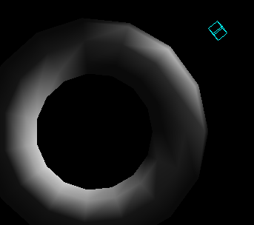

glLightfv(GL_LIGHT0,GL_POSITION,position):
- Set light-source parameters.
void glLightfv(
GLenum light,
GLenum pname,
const GLfloat *params
);

light
The identifier of a light
GL_LIGHTi where 0 ≤ i < GL_MAX_LIGHTS
At least eight lights are supported.

pname
A single-valued light-source parameter for light
param
The value to which parameter pname of light source light will be set.

Lit Sphere

#include <windows.h>
#include <gl/gl.h>
#include <gl/glu.h>
#include <gl/glut.h>
void init(void){
GLfloat mat_specular[] = { 1.0, 1.0, 1.0, 1.0 };
GLfloat mat_shininess[] = { 5.0 };
GLfloat light_position[] = { 1.0, 1.0, 1.0, 0.0 };
GLfloat white_light[] = { 1.0, 1.0, 1.0, 1.0 };
GLfloat lmodel_ambient[] = { 0.1, 0.1, 0.1, 1.0 };
glClearColor(0.0, 0.0, 0.0, 0.0);
glShadeModel(GL_SMOOTH);
glMaterialfv(GL_FRONT, GL_SPECULAR, mat_specular);
glMaterialfv(GL_FRONT, GL_SHININESS, mat_shininess);
glLightfv(GL_LIGHT0, GL_POSITION, light_position);
glLightfv(GL_LIGHT0, GL_DIFFUSE, white_light);
glLightfv(GL_LIGHT0, GL_SPECULAR, white_light);
glLightModelfv(GL_LIGHT_MODEL_AMBIENT, lmodel_ambient);
glEnable(GL_LIGHTING);
glEnable(GL_LIGHT0);
glEnable(GL_DEPTH_TEST);
}
void display(void){
glClear(GL_COLOR_BUFFER_BIT | GL_DEPTH_BUFFER_BIT);
glutSolidSphere(1.0, 20, 16);
glFlush();
}
void reshape(int w, int h){
glViewport(0, 0, (GLsizei) w, (GLsizei) h);
glMatrixMode(GL_PROJECTION);
glLoadIdentity();
if (w <= h)
glOrtho(-1.5, 1.5, -1.5*(GLfloat)h/(GLfloat)w, 1.5*(GLfloat)h/(GLfloat)w, -10.0, 10.0);
else
glOrtho(-1.5*(GLfloat)w/(GLfloat)h,1.5*(GLfloat)w/(GLfloat)h, -1.5, 1.5, -10.0, 10.0);
glMatrixMode(GL_MODELVIEW);
glLoadIdentity();
}

int main(int argc, char** argv){
glutInit(&argc, argv);
glutInitDisplayMode(GLUT_SINGLE | GLUT_RGB | GLUT_DEPTH);
glutInitWindowSize(500, 500);
glutInitWindowPosition(100, 100);
glutCreateWindow(argv[0]);
init();
glutDisplayFunc(display);
glutReshapeFunc(reshape);
glutMainLoop();
return 0;
}
Value | Meaning
GL_AMBIENT | The params parameter contains four floating-point values that specify the ambient RGBA intensity of the light. The default ambient light intensity is (0.0, 0.0, 0.0, 1.0).
GL_DIFFUSE | The params parameter contains four floating-point values that specify the diffuse RGBA intensity of the light. The default diffuse intensity is (0.0, 0.0, 0.0, 1.0) for all lights other than light zero. The default diffuse intensity of light zero is (1.0, 1.0, 1.0, 1.0).
GL_SPECULAR | The params parameter contains four floating-point values that specify the specular RGBA intensity of the light. The default specular intensity is (0.0, 0.0, 0.0, 1.0) for all lights other than light zero. The default specular intensity of light zero is (1.0, 1.0, 1.0, 1.0).
GL_POSITION | The params parameter contains four floating-point values that specify the position of the light in homogeneous object coordinates. The default position is (0,0,1,0); thus, the default light source is directional, parallel to, and in the direction of the -z axis.

Rotating Planet
Demo of Polygons, Perspective Projection, Illumination and 3D Transformation all in one program
#include <windows.h>
#include <gl/gl.h>
#include <gl/glu.h>
#include <gl/glut.h>
GLfloat x;
void init(void){
GLfloat mat_specular[] = { 1.0, 1.0, 1.0, 1.0 };
GLfloat mat_shininess[] = { 5.0 };
GLfloat light_position[] = { 1.0, 1.0, 1.0, 0.0 };
GLfloat white_light[] = { 1.0, 1.0, 1.0, 1.0 };
GLfloat lmodel_ambient[] = { 0.1, 0.1, 0.1, 1.0 };
glClearColor(1.0, 0.0, 0.0, 0.0);
glShadeModel(GL_SMOOTH);
glMaterialfv(GL_FRONT, GL_SPECULAR, mat_specular);
glMaterialfv(GL_FRONT, GL_SHININESS, mat_shininess);
glLightfv(GL_LIGHT0, GL_POSITION, light_position);
glLightfv(GL_LIGHT0, GL_DIFFUSE, white_light);
glLightfv(GL_LIGHT0, GL_SPECULAR, white_light);
glLightModelfv(GL_LIGHT_MODEL_AMBIENT, lmodel_ambient);
glEnable(GL_LIGHTING);
glEnable(GL_LIGHT0);
glEnable(GL_DEPTH_TEST);
}

void display(void)
{
glClear(GL_COLOR_BUFFER_BIT | GL_DEPTH_BUFFER_BIT);
glPushMatrix();
glRotatef(20+x,1,0,0);
glutSolidSphere(1.0, 20, 16);
glPopMatrix();
glFlush();
}
void reshape(int w, int h)
{
glViewport(0, 0, (GLsizei) w, (GLsizei) h);
glMatrixMode(GL_PROJECTION);
gluPerspective(10,w/h,1,20);
glMatrixMode(GL_MODELVIEW);
glLoadIdentity();
gluLookAt(0,0,20,0,0,0,0,1,0);
}
void move(){
x +=0.023;
glutPostRedisplay();
}
void keyboard(unsigned char key, int x, int y){
if (key == 'a')
glutIdleFunc(move);
}
int main(int argc, char** argv)
{
glutInit(&argc, argv);
glutInitDisplayMode(GLUT_SINGLE | GLUT_RGB | GLUT_DEPTH);
glutInitWindowSize(500, 500);
glutInitWindowPosition(100, 100);
glutCreateWindow(argv[0]);
init();
glutDisplayFunc(display);
glutReshapeFunc(reshape);
glutKeyboardFunc(keyboard);
glutMainLoop();
return 0;
}

Solar System
#include <windows.h>
#include <gl/gl.h>
#include <gl/glut.h>
#include <gl/glu.h>
GLfloat tx = 1;GLfloat th=0.23;
void init(){
GLfloat mat_specular[] = { 0.5, 0, 1, 1.0 };
GLfloat mat_shininess[] = { 5.0 };
GLfloat light_position[] = { 1.0, 1.0, 0, 0.0 };
GLfloat white_light[] = { 1.0, 1.0, 1.0, 1.0 };
GLfloat lmodel_ambient[] = { 0.1, 0.1, 0.1, 1.0 };
glClearColor(0.0, 0.0, 0.0, 0.0);
glShadeModel(GL_SMOOTH);

glMaterialfv(GL_FRONT, GL_SPECULAR, mat_specular);
glMaterialfv(GL_FRONT, GL_SHININESS, mat_shininess);

glLightfv(GL_LIGHT0, GL_POSITION, light_position);
glLightfv(GL_LIGHT0, GL_DIFFUSE, white_light);
glLightfv(GL_LIGHT0, GL_SPECULAR, white_light);

glLightModelfv(GL_LIGHT_MODEL_AMBIENT, lmodel_ambient);

glEnable(GL_LIGHTING);
glEnable(GL_LIGHT0);
glEnable(GL_DEPTH_TEST);
}
void display(){
glClearColor(0,0,0,1);
glClear(GL_COLOR_BUFFER_BIT | GL_DEPTH_BUFFER_BIT);
glColor3f(0.3,0.4,0.5);
glPushMatrix();
glutSolidSphere(1,20,20);
glRotatef(th,0,1,0);
glTranslatef(2,0,0);
glRotatef(th,0,1,0);
glutSolidSphere(0.2,10,10);
glPopMatrix();
glFlush();
}

void reshape(int w, int h){
glViewport(0,0,w,h);
glMatrixMode(GL_PROJECTION);
//glOrtho(0,w,0,w,-1,1);
gluPerspective(60,w/h,1,20);
glMatrixMode(GL_MODELVIEW);
gluLookAt(0,0,5,0,0,0,0,1,0);
}

void move(){
th= (th+0.03);
glutPostRedisplay();
}
void keyboard(unsigned char key, int x, int y){
if (key == 'a')
glutIdleFunc(move);
}
void main(int argc, char** argv){
glutInit(&argc, argv);
glutInitDisplayMode(GLUT_RGB | GLUT_SINGLE);
glutInitWindowSize(500,500);
glutInitWindowPosition(10,10);
glutCreateWindow("Learning OpenGL...");
init();
glutDisplayFunc(display);
glutReshapeFunc(reshape);
glutKeyboardFunc(keyboard);
glutMainLoop();
}

